**MESD LMS Documentation – Parent Teacher Communication**

**Purpose**

The purpose of this module is to facilitate communication between senior educators and the parents/guardians of learners. Since Moodle restricts messaging to only those who are enrolled in the same course, the option “Allow site-wide messaging” was activated in **Site administration > Messages > Messaging Settings** to enable parent-teacher communication.

**Usage (For Administration)**

The procedure for a Senior Educator to communicate with a parent is as follows: First, they have to access the Learner’s user profile and click on a link that will take them to the parent’s inbox. Second, they have to locate the Parent assigned to the Learner and copy the URL that corresponds to the parent’s inbox. Third, they have to paste the URL under the Parents category in the Learner’s profile. Here’s a step by step walkthrough:

1. Log in with an **Administrator** account.
2. Navigate to **Site administration > Users > Browse list of users**.
3. Select a Learner’s name to view their profile.
4. On the Learner’s profile navigate to **Administration > Preferences > Roles > Assign roles relative to this user**.

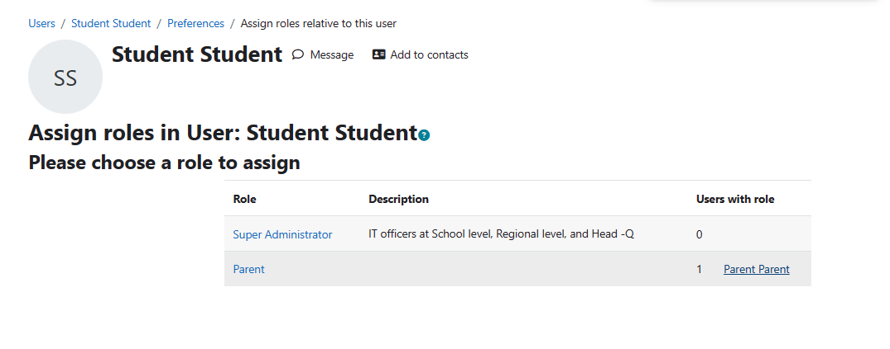

1. Click on the Parent that should be showing under **“Users with role”.**
2. Right click on the Message icon and copy the link.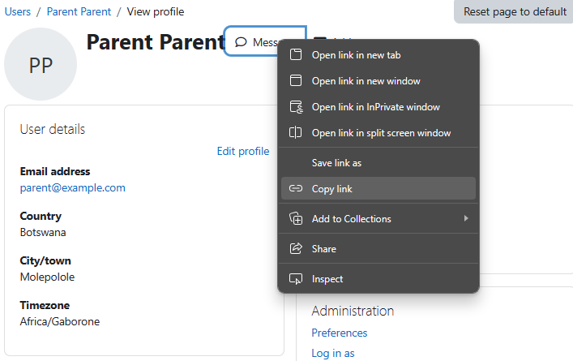
3. Go back to **Site administration > Users > Browse list of users**.
4. Go to a student account and click Edit.
5. Scroll down to **Parents** and paste the link in Web page.

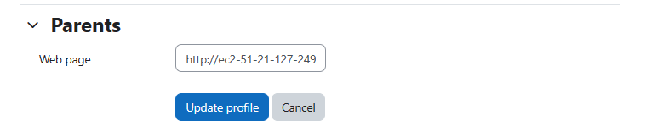

1. Click **Update profile**.

**Usage (For Senior Educator)**

1. Log in as a **Senior Educator**.
2. Navigate to your course. Select **Participants** and select the learner whose parent you’d like to communicate with.
3. Click on the link in **User details** under **Web page  
   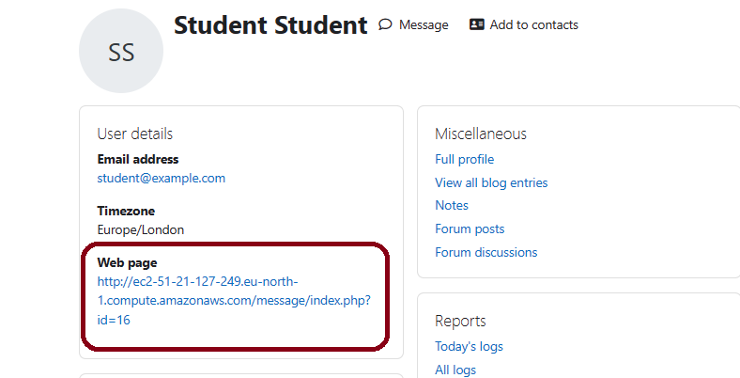**
4. Message the Parent.

